Wireless network outdoor strobe siren
local alarm system
User manual

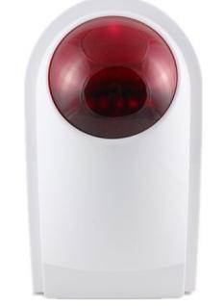

Preface
Firstly, thank you for choosing the wireless outdoor strobe siren of our company. The wireless outdoor strobe siren adopt the most advanced digital security technology from Israel with good reliability and low false alarm rate. Simple design but powerful function. It can work with any of alarm detector in 433mhz,1527, 330k. Once the detector is triggered, the wireless siren will start local 110db sound with flash lights .It is widely used in the family, shops, convenience stores, financial room, villa, residential area etc
Features
- Anti-tamper switch
- Leaning code, DIY communication with alarm host
- Build in AAA NI-MH rechargeable battery, working under the status of AC power failure
- Comply with CCC safety standard and CE certification
- Weatherproof for outdoor use
Technical parameter
- Power supply: DC 12V 1A
- Standby power consumption:≦7mA
- Alarm current:≦230mA
- Wireless frequency: 433mhz/315mhz/868mhz
- Back up battery: AAA NI-MH 7.2V
- Operating temperature:-20℃ to+55℃
- Humidity: 40% to 80% RH
- Sound volume: 110db
- Item Size: 12cm*20cm*8cm package size: 12cm*25cm*8cm. Net weight: 0.45kg
- Standard kit: Siren X1, AC power X1, white box X1, screws X2, wireless door sensor X1, wireless pir sensor X1, wireless remote control X2
Installation
Wireless siren:
The siren can be installed at the heartland of the prevent place for the best reception from all detectors. What’s more, please be sure the installation height of siren is more than 2 m. Of course, please test locally before installation to make sure the siren can get the signal from the detector normally
Wireless remote control:
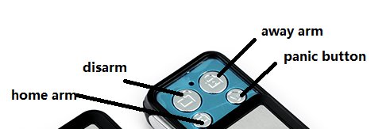
Away Arm button: The siren will alarm if the detector is triggered
Home Arm button: the siren won’t alarm if the detector at home arm zone is triggered, but alarm by trigger the other detectors at away arm zone
Disarm button: The siren won’t alarm if the detector is triggered
Adding remote control to the siren
- Press SET button 1 time, release it at once.
- Press any button on the remote control 2 times after you hear DI DI sound from the siren
Adding panic button to the siren
- Press SET button 2 times or 3 times, release it at once.
- Press any button on the panic button 2 times after you hear DI DI sound from the siren
Adding detectors to away arm zone in the siren
- Press SET button 4 times, release it at once.
- Press trigger the detectors 2 times after you hear DI DI sound from the siren
Adding detectors to home arm zone in the siren
- Press SET button 5 times, release it at once.
- Press ttrigger detectors 2 times after you hear DI DI sound from the siren

How to clear off the siren?
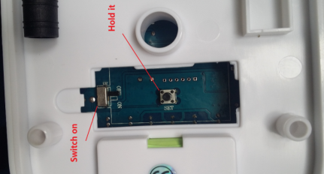
Open the back cover, you will see one SET button and Battery switch.
Firstly: hold the SET button
Secondly: swith on the battery. Please continue to hold the SET button for more than 30 seconds, and release it. the siren will clear off successfully

FAQ;
- Why the siren start alarming when i connect AC power or switch on the battery?
--------That’s because the siren get a interference signal from other place when you send the coding signal. So we advise users to make sure no other more interference signal out before you want to code detector to the siren
- Why the distance from detector to the siren is so short? Or can’t disarm normally via remote control?
--------Please check the installation height of siren is more than 2 m, at least 1 m, can’t be on the land directly. So that too many interference material will effect the distance
--------Please check the battery fully charged or not if the siren works via battery
--------Please check whether there is other interference thing between siren and detect. For example, wall, window, metallic door, electronic etc.

